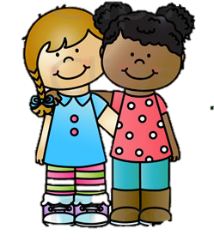

Dear Families:

We would like to start “Who is special in Kinder…” To help us do this and get to know each other, we are asking families to send a story describing your children. Some things that we would like to know are: what makes them special, things they do particularly well, how they got their name, what happened on the day they were born, who makes up their family, what they like to do for fun, their favorite book, their favorite food, and anything else you would like to share. You may add photos if you wish. We will be reading them as they come during the first two months.
Please send them in sometime soon, since we are all special and deserve this attention.

Please let us know if you have any questions.

Sincerely,

The Kindergarten Team

