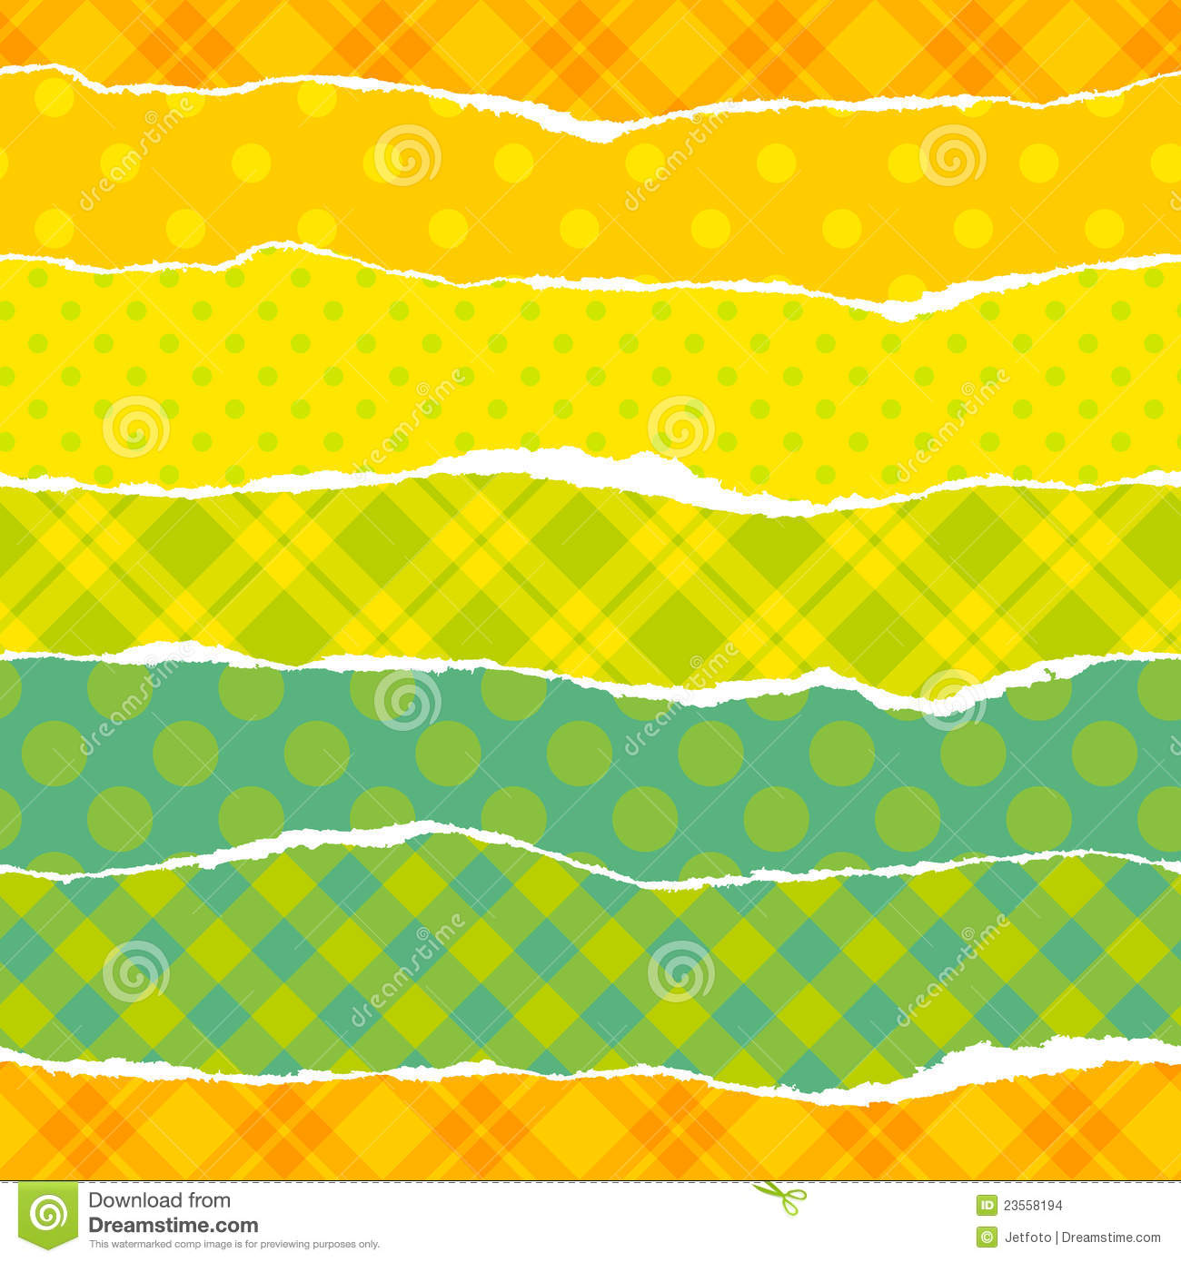
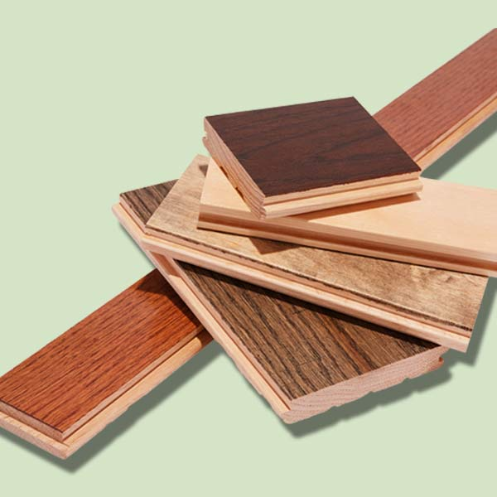
Dear Families,

Our kindergarten class is beginning a study of paper and wood next week. We will be looking at the properties of both materials (color, texture, flexibility, stiffness, etc.). In order to explore these properties, we will conduct some experiments involving paper and wood in class. We need your help to make the experiments a richer experience for your children.

If you have any interesting paper to share (i.e. wrapping paper, crepe paper, wallpaper, tissue paper, newspaper, magazines, etc.), or if you have any SMALL wood scraps at home, please send your child with the materials to school as soon as possible.

You can extend your child’s understanding of wood and paper by talking about the things he or she sees at home and around the neighborhood that are made of either paper of wood.

Gracias,

The Kindergarten Team

