LOS TRES CERDOS
Readers’ Theater for Kinder, Week 1

Characters:
Mamá Cerda
Cerdo 1
Cerdo 2
Cerdo 3
Niño/a de paja
Niño/a de palos
Niño/a de ladrillos
Lobo

Materiales:
El cuento o un video de los 3 cerditos
https://www.youtube.com/watch?v=SMmCJb3QvkE
Máscaras de cerditos y lobo
Paja (raffia), palos, ladrillos (blocks)
Casas de paja, palos, ladrillos, pintadas por los niños

Parte 1:
Put pictures of the 3 pigs, Mamá Cerdo, Lobo, and paja, palos, ladrillos on the SB message. Talk about the story (the kids will have plenty to say), and then connect the paja, palos, and ladrillos with the corresponding pigs.

Parte 2:
Read the story or show the video with the sound. Repeat the video with the sound off, stopping it throughout the action in order to introduce the vocabulary from the play. The teacher uses the visuals from the video while pre-teaching the lines of the play.

Parte 3:
The adults begin to act out the story, reading the script from the smartboard or on paper. Have adults be Mamá Cerda and el Lobo the first time. Invite students to join in as the pigs and the vendors. Adults will need to help students to get on and off stage, as well as feeding them most of the lines. (Despite this, the kids love it!)

Parte 4:
After doing the show once, invite students to take on all of the roles, prompting them as needed with the Spanish and the entrances and exits.

Parte 5:
This script and the props could easily be placed in a dramatic play center.

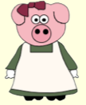
Mamá Cerda Cerdo 1 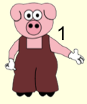
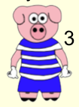
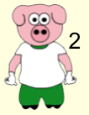

Cerdo 2 Cerdo 3

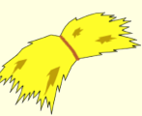
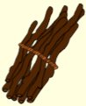
Niño/a de paja Niño/a de palos

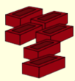
Niño/a de ladrillos

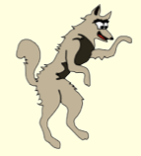
Lobo

LOS 3 CERDOS

(Mamá Cerda y los 3 cerditos)
Hola Cerdos.
Hola Mamá.
Hola Mamá.
Hola Mamá.

Adiós Cerdos.
Adiós Mamá.

Adiós Mamá.

Adiós Mamá.

Paja, paja.
Paja por favor. (Cerdo 1 hace la casa.)

Cerdo, cerdo.
No Lobo no.
Juuuuuu. Adiós Cerdo.

Palos, palos.
Palos por favor. (Cerdo 2 hace la casa.)

Cerdo, cerdo.
No Lobo no.
Juuuuuu. Adiós Cerdo.

Ladrillos, ladrillos.
Ladrillos por favor. (Cerdo 3 hace la casa.)

Cerdo, cerdo.
No Lobo no.
Juuuuuu. Juuuuu. Juuuuu.
Ja-ja-ja. Adiós Lobo.

(El Lobo se va.)

FIN

